***NAME :- V.*** ***Hrishikesh***

***REG.NO : RA2111003010972***

***SECTION : D2***

***PPS MINI PROJECT***

***C PROGRAM TO DISPLAY ATM TRANSICTION***

#include<stdio.h>

unsigned long amount=10000,withdraw,deposit;

int choice,pin,k;

char transaction ='y';

void main()

{

while (pin!=5090)

{

printf("Enter your secret pin number : ");

scanf("%d",&pin);

if(pin!=5090)

printf("PLEASE ENTER VALID PASSWARD\n");

}

do

{

printf("--------- WELCOME TO ATM SERVICES ----------\n\n\n");

printf("1.Check your account balance : \n");

printf("2.withdraw ammount \n");

printf("3.deposit ammount \n");

printf("4.Quit\n");

printf("**********************************************\n\n");

printf("Please enter your choice : ");

scanf("%d",&choice);

switch(choice)

{

case 1:

printf("\n Your bank balance in rupees : %lu",amount);

break;

case 2:

printf("\n ENTER AMOUNT TO WITHDRAW : ");

scanf("%lu",&withdraw);

if(withdraw %100 !=0){

printf("PLEASE ENTER AMOUNT IN MULTIPLES OF HUNDRED");

}

else if(withdraw > (amount - 500)){

printf("INSUFFICIENT BALANCE");

}

else{

amount=amount-withdraw;

printf("\n\nPLEASE COLLECT YOUR CASH");

printf("\ncurrent balance in your account : %lu",amount);

}

break;

case 3:

printf("Please enter amount to deposit : ");

scanf("%lu",&deposit);

amount=amount+deposit;

printf("YOUR CURRENT BNK BALANCE : %lu",amount);

break;

case 4:

printf("\n THANK YOU FOR USING OUR ATM");

break;

default:

printf("\n INVALID CHOICE");

}

printf("\n----- DO YOU WISH TO HAVE ANY OTHER TRANSCATION?(y/n) \n");

scanf("%s",&transaction);

if(transaction == 'n'|| transaction == 'N')

k=1;

}

while (!k);

printf("\n\n THANK YOU FOR USING OUR SERVICES ");

}

***SAMPLE INPUT AND OUTPUT :-***

Sample 1

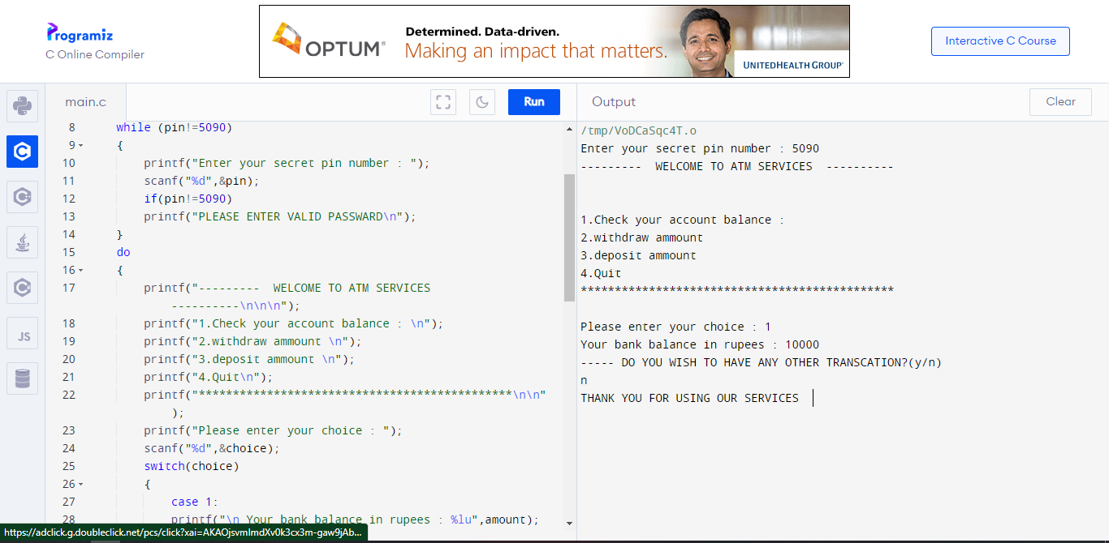

Sample 2

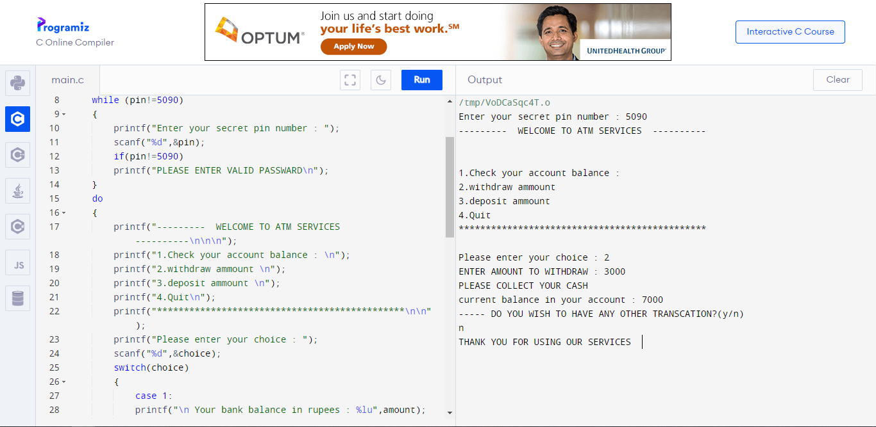

Sample 3

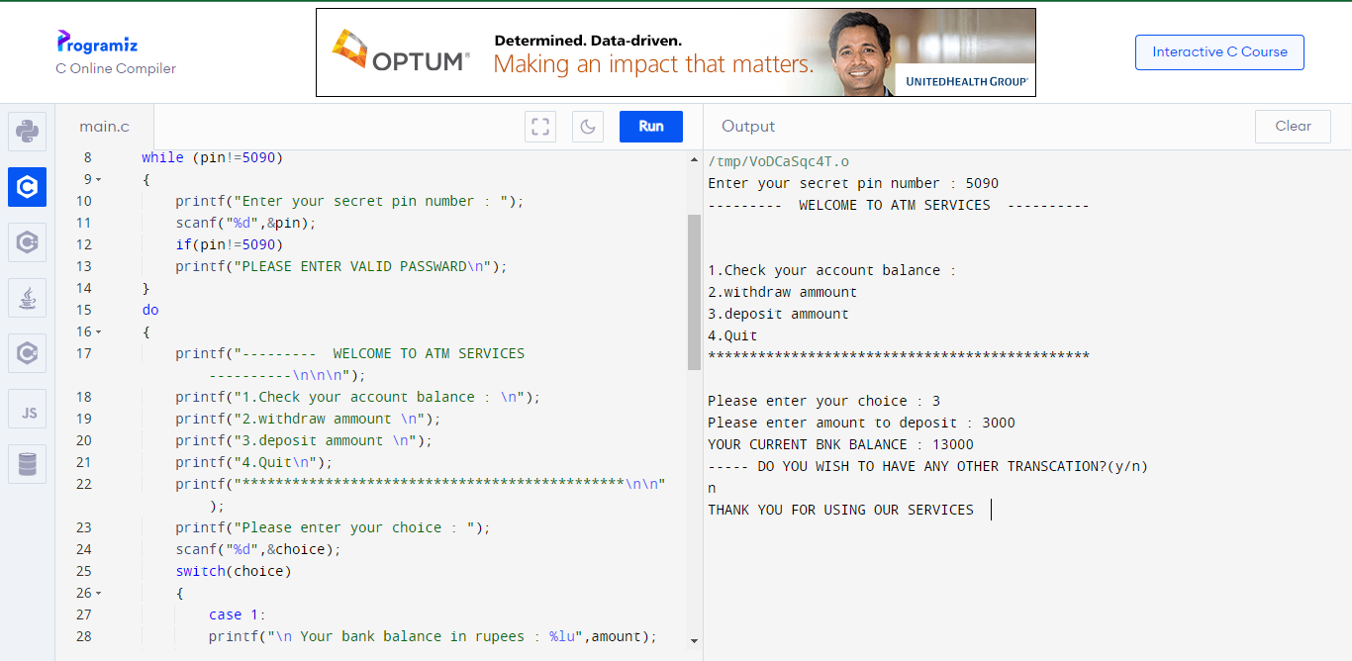

Sample 4

